**Pi:Relay Controlling using Android App (PiRelay)**

Pi:Relay is a Relay Shield for Raspberry pi. It is the best suitable device for making Home Automation and for controlling high power devices like motors, lights etc.

Using PiRelay Android App you can easily control Pi:Relay shield from anywhere from your Mobile Phone.

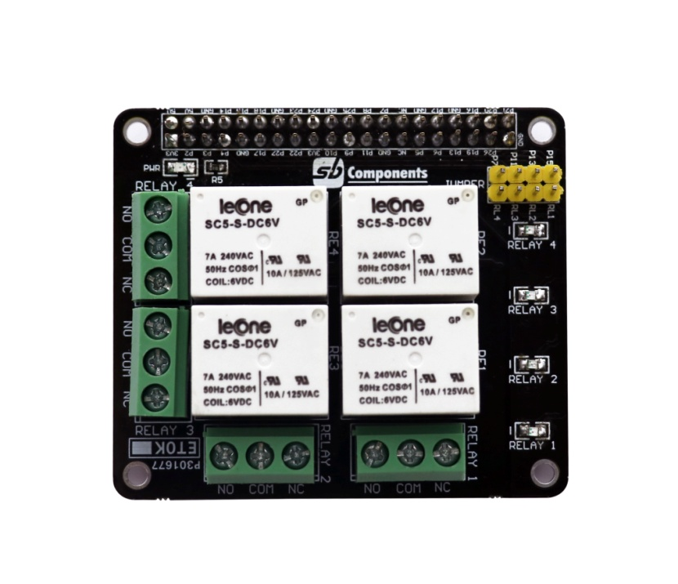

**Features of Pi:Relay:**

* 4 - High quality Relay and loads up to 7A/240VAC
* LED’s for indicating status of each relay
* 40-Pin Stacking Header for accessing GPIO of RPi.
* GPIO 4, GPIO 17, GPIO 27 and GPIO 22 are used for controlling Relay. But user can remove Relay Jumper and select custom GPIO pin.

**Connecting Pi:Relay with PiRelay Android App:**

* First follow the instructions for installing PiRelay in Raspberry Pi and Android Phone:

<https://pirelay.jasonfindlay.com/>

* Add you Raspberry Pi IP in PiRelay App. Default is <http://raspberrypi/>, go to **Settings** -> **Pi URL Addresses** and change it to your Raspberry Pi IP i.e. <http://192.xxx.xxx.xxx>.

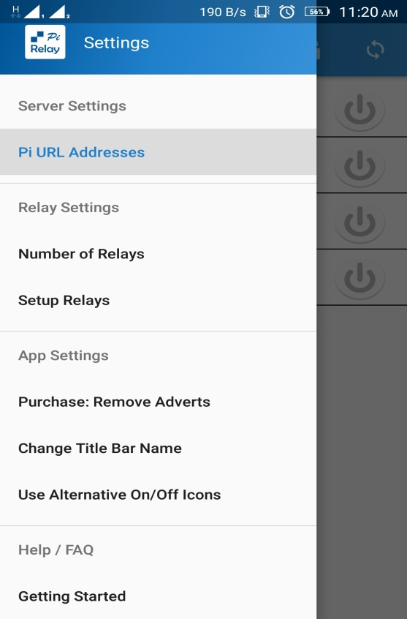 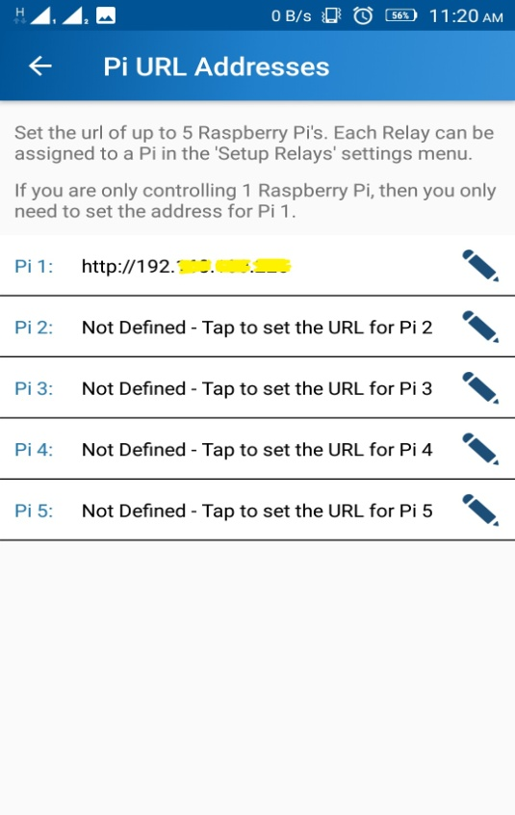

* Set number of Relays i.e. 4

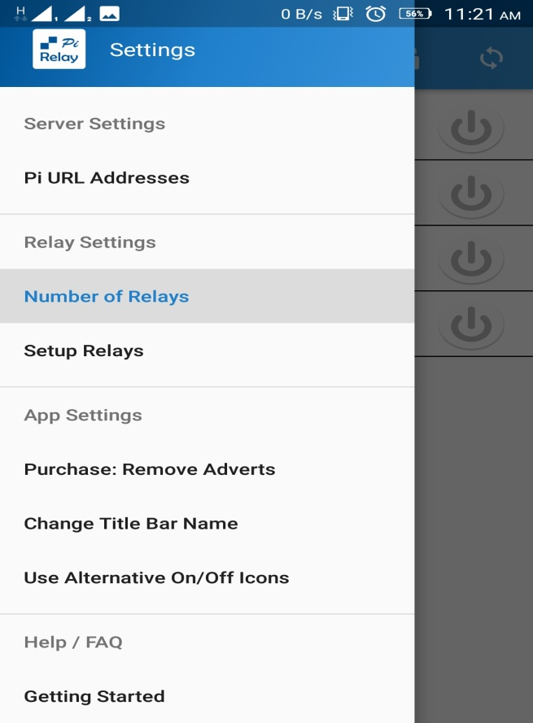

* Setup each Relay as per Wiring Pi. Because PiRelay App is using WiringPi GPIO numbering.

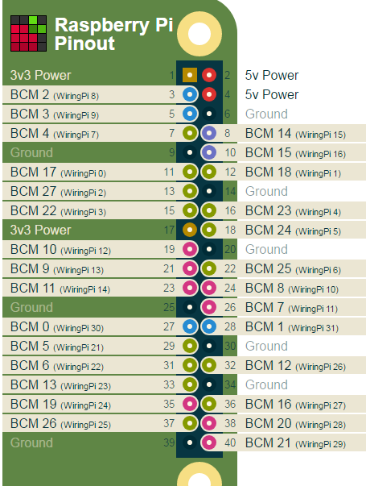 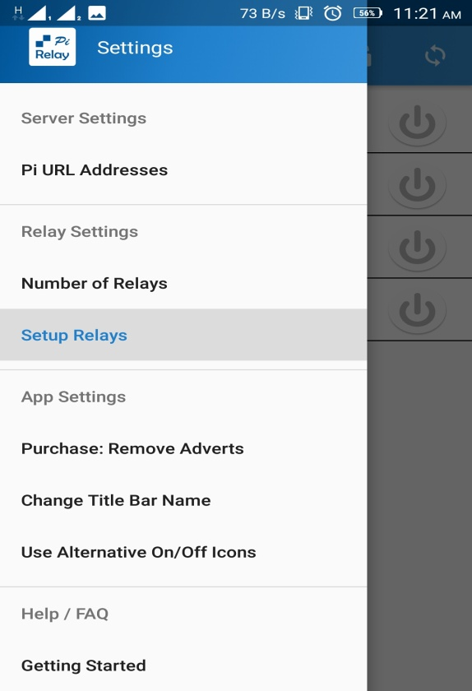

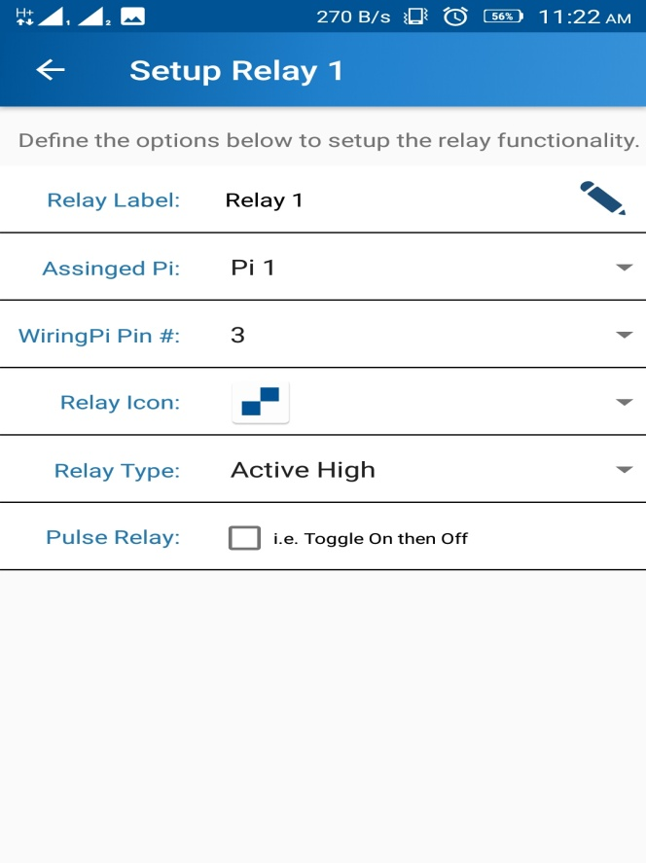 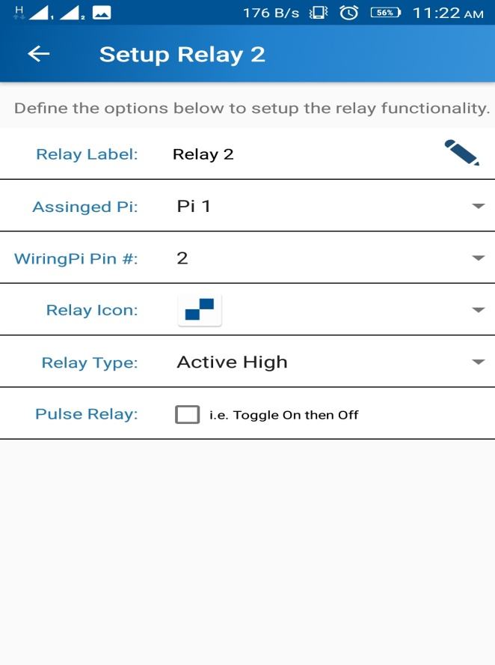

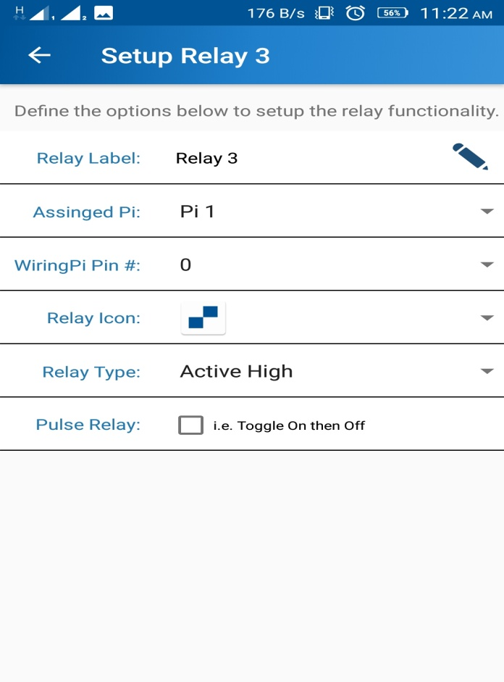 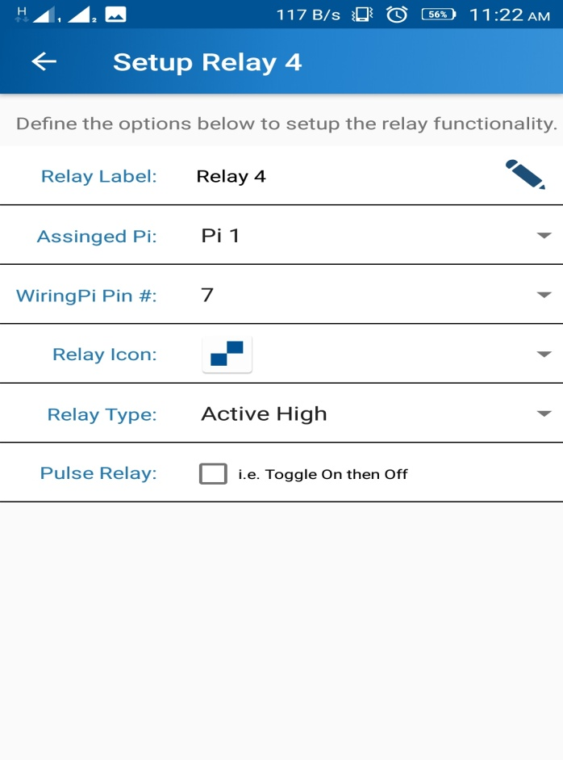

* Now everything is ready, you can test the PiRelay App and PiRelay Shield.

